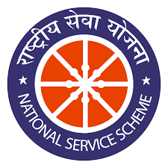
TRINITY INSTITUTE OF PROFESSIONAL STUDIES (Affiliated to G.G.S Indraprastha University, Delhi, Approved by BCI, Delhi)
“A+” Ranked Institution by SFRC, Govt. of NCT of Delhi.
Recognised under section 2(f) of the UGC Act, 1956
NAAC Accredited “B++” Grade Institution

Self attested Passport size PHOTOGRAPH

NSS

ENROLLMENT FORM

SERIAL NO: …………….

Name
Gender
Course & Shift
University Roll No.
Batch & Year
Category | SC | ST | OBC | GEN
Date of Birth
Residential Address
Blood Group
Height & Weight
NSS Group No. (Office use)
Father /Guardian’s Name
Father /Guardian’s Mobile Number
Father’s Occupation
Student Mobile No.
Student Email ID
Declaration
I hereby affirm that as a volunteer of NSS unit, (run by Government of India) will obey the rules and regulations. I will participate honestly in all the programmes of NSS. If I commit any mistake, I have no right to remain the NSS volunteer.

Signature of the NSS Volunteer

Signature of the Programme Officer Signature of the Head of the Institution

